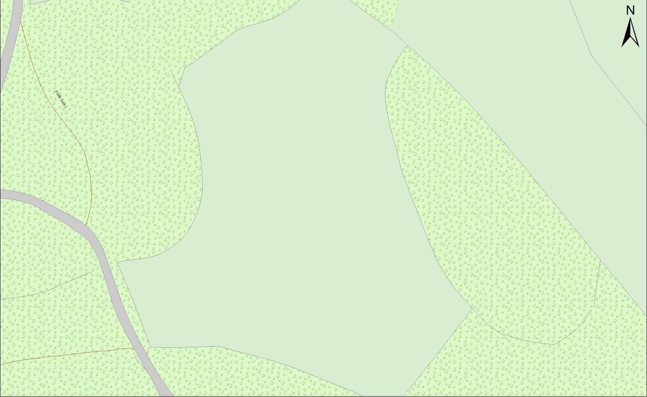

Games Marquee

Communal Fire

Shop

Showers and Toilets